Day 4
#16
import re
from collections import Counter

# Sample customer reviews dataset
reviews = [
"This product is very good and useful",
"Good quality product, very satisfied",
"Not good, the product quality is bad",
"Very useful and good product"
]

# Combine all reviews into one string
text = " ".join(reviews)

# Convert to lowercase
text = text.lower()

# Remove punctuation and special characters
text = re.sub(r'[^a-z\s]', '', text)

# Split text into words
words = text.split()

# Calculate word frequency
word_frequency = Counter(words)
print(word_frequency)
# Display the frequency distribution
print("Word Frequency Distribution:\n")
for word, count in word_frequency.items():
print(f"{word} : {count}")

output:
Word Frequency Distribution:

this : 1
product : 4
is : 2
very : 3
good : 4
and : 2
useful : 2
quality : 2
satisfied : 1
not : 1
the : 1
bad : 1

17) #17
import pandas as pd
import re
from collections import Counter
import matplotlib.pyplot as plt

# -------------------------------
# Step 1: Create CSV dataset
# -------------------------------
data = {
"feedback": [
"This product is very good",
"Good quality and useful product",
"The product is bad",
"Very useful and good quality"
]
}

df = pd.DataFrame(data)

# Save to CSV file
df.to_csv("data.csv", index=False)

# -------------------------------
# Step 2: Read CSV file
# -------------------------------
df = pd.read_csv("data.csv")

# Combine all feedback
text = " ".join(df["feedback"])

# Convert to lowercase
text = text.lower()

# Remove punctuation
text = re.sub(r'[^a-z\s]', '', text)

# Split into words
words = text.split()

# Stop words
stop_words = ["the", "and", "is", "very"]

# Remove stop words
clean_words = [word for word in words if word not in stop_words]

# -------------------------------
# Step 3: Word Frequency
# -------------------------------
word_count = Counter(clean_words)

# User input
#n = int(input("Enter number of top words: "))

top_words = word_count.most_common()
print(top_words)
# Display result
print("\nTop Frequent Words:")
for word, count in top_words:
print(word, ":", count)

# -------------------------------
# Step 4: Bar Graph
# -------------------------------
words, counts = zip(*top_words)
plt.bar(words, counts)
plt.xlabel("Words")
plt.ylabel("Frequency")
plt.title("Word Frequency Distribution")
plt.show()

output:
[('product', 3), ('good', 3), ('quality', 2), ('useful', 2), ('this', 1), ('bad', 1)]

Top Frequent Words:
product : 3
good : 3
quality : 2
useful : 2
this : 1
bad : 1
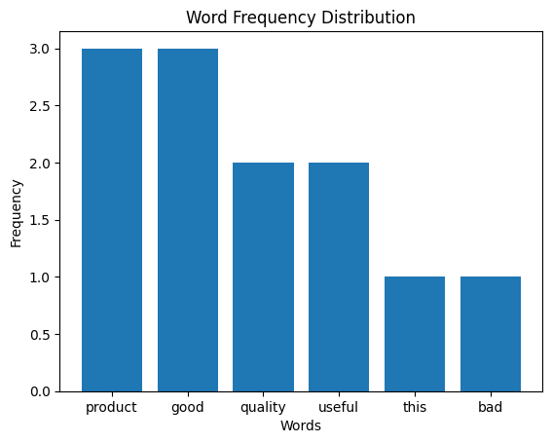

#18
import pandas as pd
import matplotlib.pyplot as plt
from scipy import stats

# Create dataset
age = [23, 23, 27, 27, 39, 41, 47, 49, 50,
52, 54, 54, 56, 57, 58, 58, 60, 61]

fat = [9.5, 26.5, 7.8, 17.8, 31.4, 25.9, 27.4, 27.2, 31.2,
34.6, 42.5, 28.8, 33.4, 30.2, 34.1, 32.9, 41.2, 35.7]

df = pd.DataFrame({"Age": age, "BodyFat": fat})

# Mean, Median, Standard Deviation
print("Mean:\n", df.mean())
print("\nMedian:\n", df.median())
print("\nStandard Deviation:\n", df.std())

# Boxplots
df.boxplot()
plt.title("Boxplot of Age and Body Fat")
plt.show()

# Scatter plot
plt.scatter(df["Age"], df["BodyFat"])
plt.xlabel("Age")
plt.ylabel("Body Fat (%)")
plt.title("Scatter Plot")
plt.show()

# Q-Q plots
stats.probplot(df["Age"], plot=plt)
plt.title("Q-Q Plot for Age")
plt.show()

stats.probplot(df["BodyFat"], plot=plt)
plt.title("Q-Q Plot for Body Fat")
plt.show()

output:
Mean:
Age 46.444444
BodyFat 28.783333
dtype: float64

Median:
Age 51.0
BodyFat 30.7
dtype: float64

Standard Deviation:
Age 13.218624
BodyFat 9.254395
dtype: float64
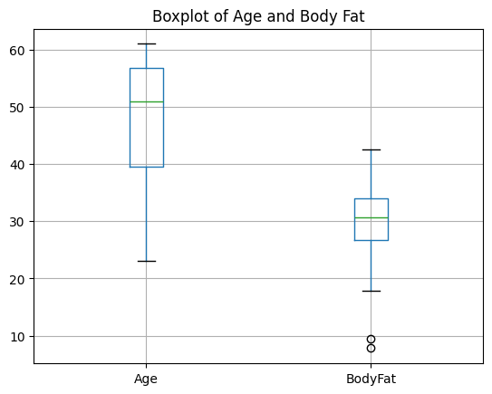
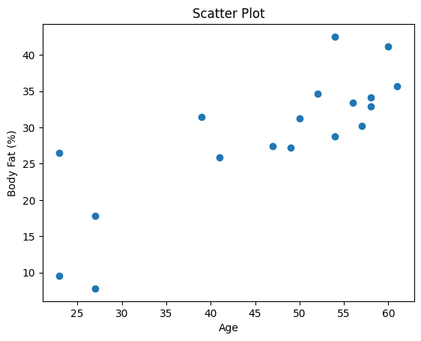
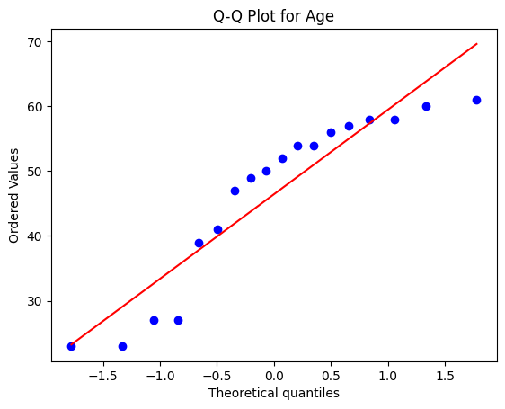
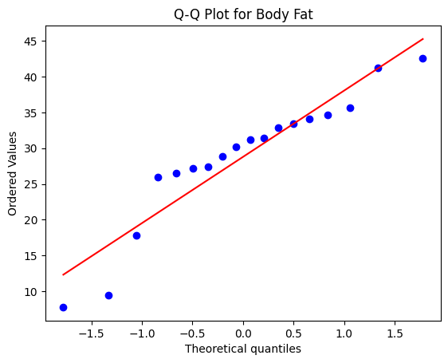
# 19
import numpy as np
import math

# Sample blood pressure reduction data
drug = [12, 10, 15, 14, 11, 13, 16, 12, 14, 15]
placebo = [3, 4, 2, 5, 3, 4, 1, 2, 3, 4]

# Function to calculate 95% confidence interval
def confidence_interval(data):
mean = np.mean(data)
print(mean)
std = np.std(data, ddof=1)
print(std)
n = len(data)
z = 1.96 # 95% confidence level
margin = z * (std / math.sqrt(n))

return mean - margin, mean + margin

# Calculate confidence intervals
drug_ci = confidence_interval(drug)
placebo_ci = confidence_interval(placebo)

print("95% CI for Drug group:", drug_ci)
print("95% CI for Placebo group:", placebo_ci)

output:
13.2
1.9321835661585918
3.1
1.1972189997378648
95% CI for Drug group: (np.float64(12.002420218384874), np.float64(14.397579781615125))
95% CI for Placebo group: (np.float64(2.3579559761487645), np.float64(3.8420440238512357))
from scipy.stats import ttest_ind

# Conversion rate data
design_A = [2.5, 3.0, 2.8, 3.1, 2.9]
design_B = [3.6, 3.8, 3.5, 3.9, 4.0]

# Perform independent t-test
t_stat, p_value = ttest_ind(design_A, design_B)

print("P-value:", p_value)

if p_value < 0.05:
print("There is a statistically significant difference.")
else:
print("There is no statistically significant difference.")

output:
P-value: 0.00018906013521384545
There is a statistically significant difference.

